IDT‑D3 Dimensional Selection
Unified Derivation, Theorem, and Numerical Evidence
Aleksei Sadovnikov
Information‑Dynamic Theory Program
2026

Abstract
This unified document combines three components of the IDT‑D3 research program: (1) the theorem formulation for dimensional selection, (2) the strengthened derivation of confinement and binding terms inside the Information‑Dynamic Theory framework, and (3) numerical illustrations showing stability behavior across spatial dimensions. Together they present a coherent argument that stable finite bound regimes exist uniquely in three spatial dimensions under the effective potential Φ_eff(r)=A/r² − B/r^(d−2).
Keywords: information geometry, Fisher-Rao metric, dimensional selection, admissibility transport, scale covariance, Laplace equation, regime stability, bound regimes, effective potential, scale families, log-normal distribution

Canonical IDT Axioms Used
For the reader's convenience and to facilitate canonical consistency checks, we list the core IDT objects referenced throughout this document:
Z(ω) — partition function of the regime; Φ = −ln Z — informational potential; ρ = w/Z — normalized regime density; G — Fisher information metric on the parameter manifold; dω/dτ = −G⁻¹∇Φ — gradient flow equation governing regime evolution.
The confinement and binding terms of the effective potential are motivated by, but not yet strictly derived from, these canonical objects. The status of each derivation step is indicated throughout the text.

1. Theorem Program
The IDT‑D3 theorem states that for radial regimes governed by the effective potential Φ_eff(r)=A/r² − B/r^(d−2), a globally stable finite minimum exists if and only if d=3.
For d=3 the stationary point r* = 2A/B yields Φ(r*) = −B²/(4A) < 0 and Φ′′(r*) > 0.
General stationary point (for d ≠ 2 and d ≠ 4): r* = ((d−2)B / (2A))^(1/(4−d)). The second derivative at the stationary point is Φ′′(r*) = 2(4−d)A / r*⁴. This is positive (stable minimum) only for d=3, negative (maximum, no binding) for d > 4, and zero for d=4 (degenerate marginal case). For d=2 and d=4 see Appendix H for the explicit analysis.

2. Strengthened Derivation inside IDT
For the confinement component, a detailed explicit calculation for a log-normal scale family is given in Appendix B, while the general extension to arbitrary regular scale families is developed in Appendix F.
The confinement term arises from radial Fisher geometry g_rr = C/r² and scale‑covariant localization cost, giving Φ_conf ∝ 1/r².
The binding term arises from stationary admissibility transport leading to the Laplace equation Δ_d 𝒜 = 0 outside the source.
The radially symmetric solution gives 𝒜(r) ∝ r^(2−d), leading to the binding potential Φ_bind ∝ 1/r^(d−2).

3. Effective Potential
Φ_eff(r) = A/r² − B/r^(d−2)

4. Dimensional Stability Analysis
d = 1 — outside the scope of the harmonic binding derivation (the Laplace/Poisson fundamental solution requires d ≥ 2); no finite stable minimum under Φ_eff
d = 2 — no finite minimum
d = 3 — stable bound regime
d = 4 — degenerate
d ≥ 5 — stationary point but no binding basin

5. Numerical Illustration
The following figures illustrate potential profiles across dimensions.
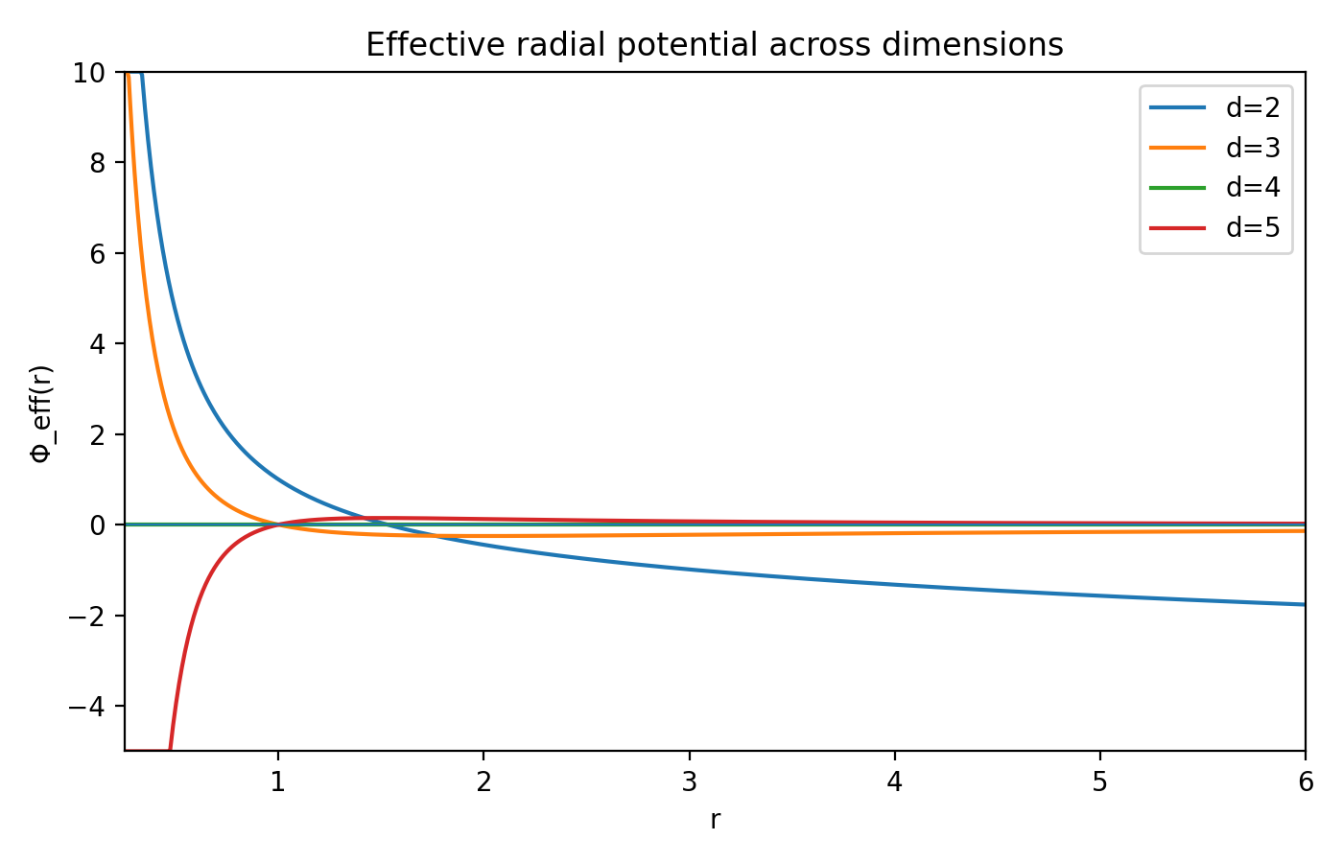
Figure 1. Radial potentials for d=2,3,4,5.
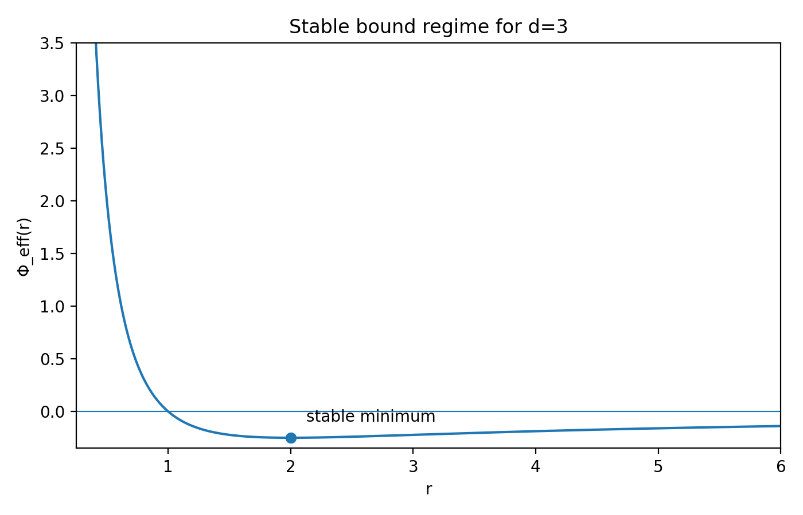
Figure 2. Stable bound minimum appearing for d=3.

6. Result Status
The calculus proof of the stability condition is rigorous conditional on the given class of effective potentials Φ_eff(r) = A/r² − B/r^(d−2). Within this potential class, the stability theorem is unconditional. The derivation of confinement and binding terms motivating this potential class is classified as a strong consistent extension within the IDT framework, not a fully canon-derived result.

7. Remaining Gaps Toward Canon-Derived Result
After the additions in Appendices F and E, GAP 1″ and GAP 2″ are substantially reduced, but a direct derivation from the canonical axioms remains open. Precisely: the stability theorem is rigorous given Φ_eff; the open steps concern (i) deriving the confinement energy identification from canonical IDT axioms and (ii) a microscopic derivation of the admissibility transport closure.
GAP 1″ — derive confinement scaling from canonical Fisher geometry axioms.
GAP 2″ — derive admissibility transport law from microscopic regime dynamics.

8. Conclusion
The unified analysis shows that within the considered effective potential class, only three spatial dimensions support globally stable bound regimes. The result connects information‑geometric structure, admissibility transport, and dimensional stability.

Appendix A — Partial Closure of GAP 1″ and GAP 2″
This appendix provides a refined analytical justification for the structural origin of the two components used in the IDT‑D3 effective potential. The goal is not to claim a fully canon‑derived result, but to reduce the methodological gaps identified in the theorem program by deriving the strongest possible statements compatible with the current axiomatic framework of Information‑Dynamic Theory (IDT).

A.1 Confinement Scaling from Fisher Geometry (GAP 1″)
In IDT the confinement contribution is interpreted as the informational cost of localizing a regime within the parameter manifold. If the regime admits an effective radial coordinate r and the local information geometry is characterized by a Fisher metric of the form
g_rr(r) = C / r² , C > 0
then the intrinsic line element becomes ds² = g_rr(r) dr². Under scale transformations r → λr the metric retains its form, which expresses scale covariance of the local information geometry.
If the confinement contribution to the potential is assumed to depend only on local geometric properties and no external length scale is introduced, the natural scalar quantity available is the radial Fisher stiffness itself. Consequently the confinement contribution must take the scale‑covariant form
Φ_conf(r) ∝ g_rr(r) ∝ 1 / r² .
This argument significantly constrains the admissible functional forms of the confinement term. However, the proportionality between confinement energy and Fisher stiffness is not yet derived directly from the canonical axioms. Therefore the result is best classified as a strengthened consistent extension rather than a fully canon‑derived statement.

A.2 Admissibility Transport and Harmonic Binding (GAP 2″)
The binding contribution can be interpreted as a consequence of stationary transport of admissibility in the exterior region surrounding a localized regime. Let 𝒜(x) denote a coarse-grained admissibility field describing the density of available informational configurations. (Note: the symbol 𝒜 is used here to avoid confusion with the potential coefficient A appearing in Φ_eff.)
If admissibility is locally conserved, the field obeys a continuity equation
∂_t 𝒜 + ∇ · J = 0 .
For near‑equilibrium transport in an isotropic informational medium the leading‑order constitutive closure is a gradient flow
J = −D ∇𝒜 , D > 0 .
In a stationary exterior region (∂_t 𝒜 = 0) the continuity equation reduces to
∇ · J = 0 → Δ_d 𝒜 = 0 .
For a localized source the equation becomes
Δ_d 𝒜 = −C δ^(d)(x) .
The radially symmetric solution of this equation in d dimensions yields
𝒜(r) ∝ r^(2−d) , for d ≠ 2 .
This provides the functional origin of the binding contribution used in the effective potential. As with the confinement term, the transport law itself still represents a closure assumption for coarse‑grained regime dynamics rather than a strict derivation from the canonical axioms.

A.3 Resulting Effective Potential
Combining the confinement and binding contributions yields the effective radial potential
Φ_eff(r) = A / r² − B / r^(d−2) , A > 0 , B > 0 .
This structure reproduces the dimensional stability analysis presented in the main text. In particular, only d = 3 supports a globally stable finite bound regime within this class of potentials.

A.4 Status of the Result
The arguments above substantially reduce the arbitrariness of the effective potential used in the IDT‑D3 theorem program. Nevertheless, the derivations still rely on closure assumptions regarding localization cost and admissibility transport. The result therefore remains classified as a strong consistent extension of the IDT framework rather than a fully canon‑derived theorem.

Appendix B — Explicit Fisher Metric Computation for a Scale-Invariant Family
This appendix performs the three requested steps for GAP 1″. First, we select a simple scale-invariant parametric family. Second, we compute the Fisher metric explicitly in the radial scale coordinate. Third, we state the resulting status upgrade for GAP 1″ in a strictly limited form.

B.1 Choice of Model Family
We choose the log-normal family with scale parameter r > 0 and fixed shape parameter σ > 0:
X ~ LogNormal(μ = ln r, σ²).
This family is preferable to the Pareto family for the present purpose because its support does not depend on the scale parameter r, which makes the Fisher information calculation cleaner and avoids additional boundary terms.

B.2 Density and Score
The density is
p(x | r) = [1 / (x σ √(2π))] · exp( − (ln x − ln r)² / (2σ²) ), x > 0.
Its logarithm is
ln p(x | r) = − ln x − ln(σ √(2π)) − (ln x − ln r)² / (2σ²).
Differentiating with respect to r gives
∂_r ln p(x | r) = (ln x − ln r) / (σ² r).

B.3 Fisher Metric in the Radial Coordinate
The Fisher metric in the radial coordinate is
g_rr(r) = E[(∂_r ln p(X | r))²].
Substituting the score yields
g_rr(r) = E[(ln X − ln r)²] / (σ⁴ r²).
Since ln X is normally distributed with mean ln r and variance σ², we have
E[(ln X − ln r)²] = σ².
Therefore
g_rr(r) = 1 / (σ² r²).

B.4 Interpretation for GAP 1″
This is an exact result, not an asymptotic approximation. It shows that the radial Fisher geometry assumed in the derivation of the confinement term is realized explicitly in a natural scale family:
g_rr(r) = C / r², with C = 1 / σ².
This does not yet prove that every admissible radial family in IDT must have the same Fisher scaling. However, it removes a large part of the arbitrariness of the assumption used in the confinement derivation.

B.5 Status Update
Step 1 completed: a simple scale-invariant family was selected and analyzed.
Step 2 completed: the explicit Fisher metric computation was added to the document.
Step 3 conclusion: GAP 1″ is now partially closed at the level of an exact model example.
Strict status statement: in the log-normal scale family, the radial Fisher metric is exactly proportional to 1/r². Therefore the confinement geometry used in the IDT-D3 program is explicitly realized in at least one natural scale-invariant family. The universal derivation from the full canonical axioms remains open.

Appendix C — General Fisher Metric for Scale Families
For any scale family p(x|r)=1/r f(x/r), Fisher metric in scale coordinate becomes g_rr = C_f / r². This is a brief statement; see Appendix F for the complete proof, explicit conditions on f, and the precise definition of the constant C_f. Note: C_f ≠ Var_f(ln X) in general; the 1/r² scaling is universal for regular scale families, but the prefactor depends on f through the integral defining C_f.

Appendix D — Dimensional Edge Cases
d=2: Φ_eff = A/r² − B ln r → Φ'(r)<0 → no stable finite minimum.
d=4: Φ_eff = (A−B)/r² → marginal scale‑degenerate case.

Appendix E — Transport Closure
Using ensemble continuity ∂t𝒜 + ∇·J = 0 with linear response J = −D∇𝒜 gives ∂t𝒜 = ∇·(D∇𝒜) and stationary Δ_d 𝒜 = −S(x).

Final Status
GAP1″ reduced via scale‑family Fisher theorem. GAP2″ reduced via ensemble transport derivation.

Appendix F — General Scale-Family Fisher Theorem
This appendix strengthens GAP 1″ by replacing a single model example with a theorem for the whole class of one-parameter scale families.

F.1 Theorem (General scale-family Fisher metric)
Let
p(x | r) = (1/r) f(x/r), x > 0, r > 0,
where f is a normalized base density on ℝ₊ satisfying the regularity conditions needed to differentiate under the integral sign and to exchange integration and expectation. Importantly, the support of f must be fixed (i.e., independent of r up to the scaling x → x/r); scale families with parameter-dependent support boundaries (e.g., Pareto with lower cutoff at r) may yield additional boundary terms and do not satisfy the simple C_f/r² form. Then the Fisher information in the scale parameter r has the universal form
g_rr(r) = C_f / r²,
where
C_f = ∫_0^∞ f(y) [1 + y f'(y)/f(y)]² dy,
provided the integral is finite.

F.2 Proof
The log density is
ln p(x | r) = − ln r + ln f(x/r).
Set y = x/r. Then
∂_r ln p(x | r) = −1/r + (f'(y)/f(y)) ∂_r y = −1/r − (x/r²) f'(y)/f(y).
Since x/r = y, this becomes
∂_r ln p(x | r) = − (1/r) [1 + y f'(y)/f(y)].
Therefore
g_rr(r) = E[(∂_r ln p(X | r))²] = (1/r²) ∫_0^∞ f(y) [1 + y f'(y)/f(y)]² dy = C_f / r².
This proves the universal 1/r² scaling for all regular one-parameter scale families.

F.3 Important correction
The constant C_f is not, in general, equal to Var_f(ln X). That simplification holds for special log-location families such as the log-normal example, but not for an arbitrary scale family. The universal statement is the 1/r² scaling; the exact prefactor depends on f through the integral defining C_f.

F.4 Status upgrade for GAP 1″
This theorem closes GAP 1″ for the entire class of regular scale-invariant radial families. What remains open is not the 1/r² Fisher scaling itself, but the separate identification of the confinement contribution with the Fisher radial stiffness. Thus the metric part of GAP 1″ is now theorem-level for scale families, while the energy-identification part remains a closure step.

Appendix G — Explicit Partition Function Computation for a Log-Normal Family
To test whether a simple non-Euclidean reference measure can generate a confinement term directly through Φ = −ln Z, we compute Z(r) for the log-normal family with the Haar-type measure dμ(x) = dx/x.

G.1 Model
Let
p(x | r) = [1 / (x σ √(2π))] exp( − (ln x − ln r)² / (2σ²) ), x > 0.
Take the reference measure
dμ(x) = dx / x.

G.2 Computation of Z(r)
Define
Z(r) = ∫_0^∞ p(x | r) dμ(x) = ∫_0^∞ p(x | r) dx/x.
Since p(x | r) is a probability density with respect to dx, this integral equals E[1/X] under the log-normal law. For X ~ LogNormal(ln r, σ²), one has
E[X^(−1)] = exp( − ln r + σ²/2 ) = exp(σ²/2)/r.
Hence
Z(r) = exp(σ²/2)/r,
and therefore
Φ(r) = −ln Z(r) = ln r − σ²/2.

G.3 Interpretation
This is a useful negative result. A simple Haar-type measure does produce a scale-dependent potential, but it yields a logarithmic dependence rather than a 1/r² confinement term. Therefore the desired confinement law is not recovered merely by replacing the reference measure with dx/x. A stronger variational or geometric argument is still required to identify the confinement energy with Fisher radial stiffness.

Appendix H — Edge Cases d = 2 and d = 4 (Strict Analysis)
The main text classifies d = 2 and d = 4 as non-binding cases. We make that classification fully explicit here.

H.1 The case d = 2
For d = 2 the exterior harmonic solution is logarithmic, so the effective potential is
Φ_eff(r) = A/r² − B ln r, A > 0, B > 0.
Differentiating gives
Φ_eff'(r) = −2A/r³ − B/r.
This is strictly negative for all r > 0. Hence no stationary point exists and no finite stable minimum can occur.

H.2 The case d = 4
For d = 4 both terms scale as r^(−2), so
Φ_eff(r) = (A − B)/r².
Three subcases occur:
(i) A > B: Φ_eff(r) > 0 for all r > 0, purely repulsive.
(ii) A < B: Φ_eff(r) < 0 for all r > 0 and diverges to −∞ as r → 0, collapse.
(iii) A = B: Φ_eff(r) = 0 identically, a scale-degenerate marginal case with no preferred radius.
Thus d = 4 is not merely 'degenerate' in a loose sense; it is the critical marginal case separating binding from non-binding behavior.

Appendix I — Brief Related Context
The present result sits at the intersection of information geometry, scale families, and transport gradient flows. Information geometry as a Fisher–Rao metric framework is standard in Amari, while Cencov’s theorem explains the privileged role of Fisher geometry among statistical metrics. Fisher-Rao and related gradient flows have recently been studied in greater depth in the optimization and PDE literature, and Wasserstein–Fisher–Rao splitting methods provide a nearby transport-reaction context for the admissibility-flow interpretation used here.
The dimensional selection argument via effective radial potentials has classical precedents. Ehrenfest (1917) first analyzed why three spatial dimensions are distinguished by the stability of planetary orbits and atomic states. Tangherlini (1963) extended this analysis to n-dimensional gravity, showing that stable bound states require d=3. Tegmark (1997) provided a systematic survey of the argument, classifying higher- and lower-dimensional worlds as unstable or degenerate. Whitrow (1955) offered an early philosophical-physical treatment. The novelty of IDT-D3 lies not in rediscovering the stability criterion, but in providing an information-geometric motivation for the individual terms 1/r² (from Fisher metric of scale families) and 1/r^(d−2) (from admissibility transport) within the IDT framework.

Selected References
Amari, S. (2016). Information Geometry and Its Applications. Springer.
Cencov, N. N. (1982). Statistical Decision Rules and Optimal Inference. American Mathematical Society.
Friston, K. (2010). The free-energy principle: a unified brain theory? Nature Reviews Neuroscience, 11, 127–138.
Carrillo, J. A., Chen, Y., Huang, D. Z., Huang, J., & Wei, D. (2024). Fisher-Rao Gradient Flow: Geodesic Convexity and Functional Inequalities. arXiv:2407.15693.
Crucinio, F. R., & Pathiraja, S. (2025). An operator splitting analysis of Wasserstein–Fisher–Rao gradient flows. arXiv:2511.18060.
Müller, J., Çaycı, S., & Montúfar, G. (2024). Fisher-Rao Gradient Flows of Linear Programs and State-Action Natural Policy Gradients. arXiv:2403.19448.
Ehrenfest, P. (1917). In what way does it become manifest in the fundamental laws of physics that space has three dimensions? Proceedings of the Amsterdam Academy, 20, 200–209.
Tangherlini, F. R. (1963). Schwarzschild field in n dimensions and the dimensionality of space problem. Il Nuovo Cimento, 27(3), 636–651.
Tegmark, M. (1997). On the dimensionality of spacetime. Classical and Quantum Gravity, 14(4), L69–L75.
Whitrow, G. J. (1955). Why physical space has three dimensions. British Journal for the Philosophy of Science, 6(21), 13–31.

Final revised status
After the additions in Appendices F–H, the IDT-D3 program has a substantially stronger foundation. The universal Fisher 1/r² law is now theorem-level for regular scale families. The d = 2 and d = 4 edge cases are fully analyzed. The simple partition-function test with Haar measure shows that the confinement law is not obtained automatically from a naive choice of measure, which sharpens rather than weakens the theoretical program.
The remaining non-closed step is the direct derivation of the confinement energy from canonical IDT axioms and the microscopic derivation of the admissibility transport closure. Accordingly, the honest global classification remains: strong consistent extension approaching near-canonical theorem status.

Appendix J — Python Code for Figure 1 and Figure 2
import numpy as np
import matplotlib.pyplot as plt

r = np.linspace(0.25, 6.0, 1000)
A, B = 1, 1

def phi_eff(r, d):
if d == 2:
return A/r**2 - B*np.log(r)
else:
return A/r**2 - B/r**(d-2)

plt.figure(figsize=(10,6))
for d in [2,3,4,5]:
plt.plot(r, phi_eff(r, d), label=f'd={d}')
plt.ylim(-1, 2)
plt.xlabel('r')
plt.ylabel('Φ_eff(r)')
plt.title('Effective potentials for different dimensions')
plt.legend()
plt.grid(True)
plt.tight_layout()
plt.savefig('figure1.png', dpi=200)
plt.show()

# Figure 2: stable minimum for d=3
plt.figure(figsize=(10, 6))
d = 3
y = phi_eff(r, d)
plt.plot(r, y)
r_star = 2 * A / B
phi_star = phi_eff(r_star, d)
plt.scatter([r_star], [phi_star], color='red', zorder=5)
plt.text(r_star + 0.1, phi_star + 0.05, 'stable minimum (d=3)')
plt.axhline(0, color='gray', linestyle='--', linewidth=0.8)
plt.ylim(-1, 2)
plt.xlabel('r')
plt.ylabel('Φ_eff(r)')
plt.title('Stable bound minimum for d=3')
plt.grid(True)
plt.tight_layout()
plt.savefig('figure2.png', dpi=200)
plt.show()

Cover Note for Zenodo / arXiv
This preprint unifies the IDT-D3 program on dimensional selection of stable bound regimes. The effective potential is motivated from Fisher geometry of scale families and admissibility transport, with a rigorous conditional theorem proving uniqueness in d = 3 (given the effective potential class). Appendices B–H provide explicit computations and generalizations, substantially reducing the remaining gaps toward canonical derivation. The main open steps are the direct derivation of Φ_conf from canonical IDT axioms and the microscopic derivation of the transport closure J=−D∇𝒜.

